The River Centre 3-16 Learning Community
  - primary campus
  - Half termly Newsletter
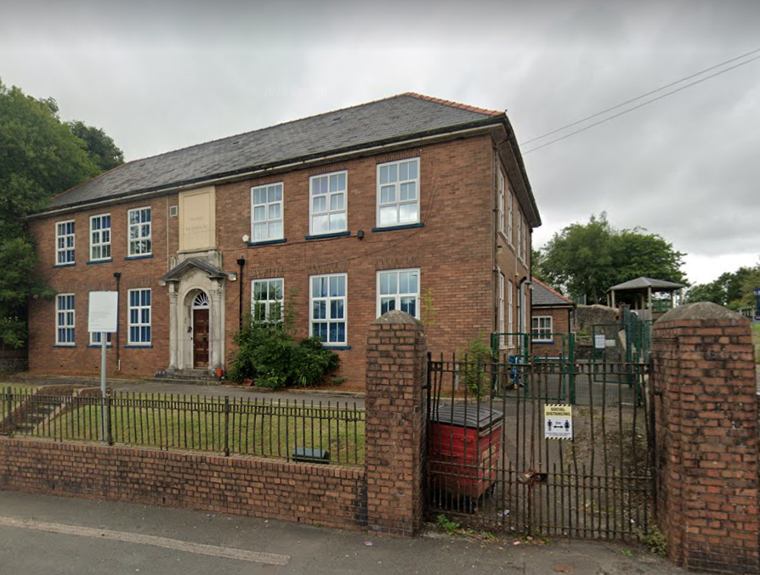
Events:  - Meet the Teacher  - Coffee Morning  - Trip to British Bird of Prey Centre  - Ugly Bug Ball  - Harvest Festival  - Cinema Fundraiser  - AS Animal Encounters  - STEM Carousel Day | Term dates:  - Half Term  31st October – 4th November 2022  - Autumn Term 2  7th November – 22nd December 2022

Curriculum for wales
“The Curriculum and Assessment (Wales) Act 2021 (the Act) established the Curriculum for Wales in law and replaced the basic curriculum.” The Curriculum for Wales came into effect in September 2022. “A school’s curriculum is everything a learner experiences in pursuit of the four purposes. It is not simply what we teach, but how we teach and crucially, why we teach it.”
https://hwb.gov.wales/curriculum-for-wales/introduction/

Dosbarth…
  - Find out what your child has been learning in their class during this half-term’s topic theme ‘It’s a bugs life.’
  - Coch
Pupils had the opportunity to hold bugs during an animal encounter. They explored the relationships between living things, their habitats and lifecycles. Pupils looked at the lifecycle of a butterfly and also created one using clay. They produced a symmetrical butterfly using paints. Pupils re-enacted the story of the very hungry caterpillar using self-made stick puppets and also engaged in a puppet show. Pupils created a story map of the snail trail and made snails from clay. They also took part in an Autumn walk to find a leaf and described it using adjectives.
  - Glas
During the STEM carousel day, Pupils investigated different forms of energy and made a butterfly. Pupils were able to handle African snails, millipedes and cockroaches during an animal encounter. Pupils investigated bugs in the school forest area and explored bugs habitats and their life cycles. They also created bugs using clay. Pupils listened to the flight of the bumblebee. They designed an Ugly Bug Ball poster and spent a wellbeing afternoon making Halloween decorations. Pupils also leant about the Black Death and drew a mask.
  - gwyrdd
Pupils engaged in Duke of Edinburgh type (outdoor learning) activities, such as paddle boarding, mountain walking, caving and rock climbing. They participated in craft activities and created bug’s life art. Pupils explored the lifecycles and habitats of bugs. They created their own music that was inspired by Korsakou’s Flight of the Bumblebee and Halloween. Pupils completed step by step minibeast drawing. They wrote their own descriptive scary story. The History of Harvest was looked at in preparation for the Harvest Festival. Pupils looked at symmetry in butterflies and creative activities. They learned how to read, write and interpret large numbers and how to round numbers. Pupils also looked at current world affairs.
  - Melyn
During the topic theme, ‘It’s a Bugs Life’, pupils measured insects and created a bug house. Pupils had the opportunity to hold bugs during an animal encounter. They designed a bug themed hero and wrote a creative story about the hero. Pupils wrote a letter to a pen pal and created a comic strip. Using the theme, pupils created bug fact files, bug models, symmetry, Venn diagrams, bug timetables and created bug 2D and 3D shapes. During a P.E. lesson, Pupils used bug moves. Pupils also engaged in a puppet show.

