Universal Credit Migration – Support for Residents
What is happening?
From April 2024 the Department for Works and Pensions (DWP) are migrating working age customers in receipt of legacy benefits to Universal Credit (UC).
How will the DWP contact residents?
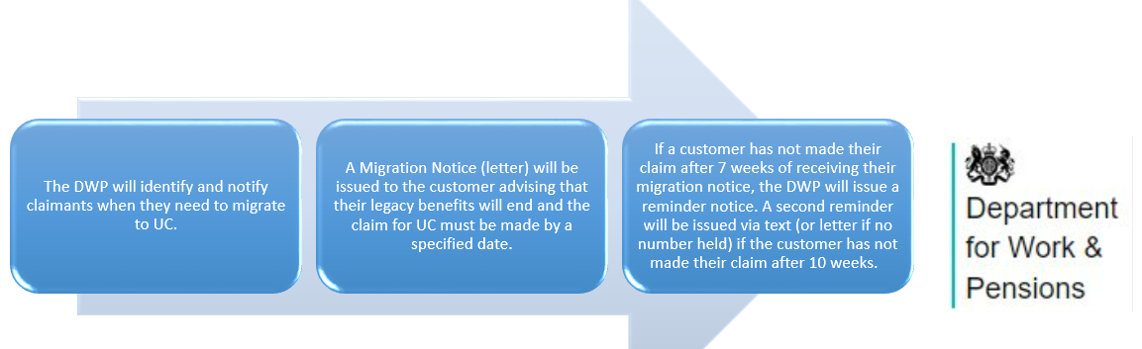
What does this mean for our residents?
- Residents will be given three months and 1 day to make the claim for UC.
- Residents may need to provide evidence to support the claim.
- If residents need additional support/time to make the claim, the DWP provide a freephone number 0800 169 0328 to call for support.
- If residents do not make the claim by the date provided, their current benefits will end.
Resident Challenges
- Current Housing Benefit payments are paid either every 4 weeks, direct to the Landlord or every two weeks, direct to the resident. UC payments are paid once a month in arrears.
- It takes around five weeks for the UC payment to be processed.
- A UC payment in advance is available, however, this must be repaid.
- Residents may require additional support regarding budgeting due to the possible change in amounts and frequency of the UC payment.
- Residents may find the digital/online process difficult to follow.
What support is available for our residents?
Blaenau Gwent Council Community Hubs​

- Provide advice regarding applying for UC and UC Advance payments.​
- Provide budgeting advice/support if there are delays in receiving the UC payment.​
- Can direct residents to third party organisations who can provide fuel and food support. ​
- Liaise with the Council Tax department, as residents who have claimed UC may not be able to meet their payment by the date specified.​
- Liaise with Housing Associations such as Tai Calon if residents are struggling to meet rent payments.​
- Issue Fuel and Food Vouchers to residents in urgent need.

Digital Exclusion
​
- Digital Officer attends BG libraries daily, supporting residents to increase digital capabilities.​
- Digital Officer can support residents to make a claim for UC. ​
- For residents already moved to UC, support can be provided regarding accessing journals and making changes to UC claim.​
- Can support residents to set up online bank accounts. ​

The Department for Works and Pensions (DWP)​

- Provides online support for residents moving to UC - Move to Universal Credit - Move to Universal Credit (ucmove.campaign.gov.uk) ​
- Provides telephone support for customers who are unable to access support online. They have a dedicated free phone number - Move to UC Helpline 0800 169 0328 ​
- The DWP also offers customers help with making an application - Help to Claim offers free, independent, confidential and impartial support over the phone to help people make a claim to Universal Credit, delivered by trained advisers from Citizens Advice. Citizens Advice Wales – 0800 144 8444 ​

Smart Money – A financial cooperative community bank owned by its members. Smart Money Provides residents with the opportunity to open a Smart Money bank account. ​
Smart Money Cymru Community Bank | Online Banking ​

Welsh Water – Offers a ‘Help U’ tariff for households on a low income. ​
HelpU tariff | Dŵr Cymru Welsh Water (dwrcymru.com)​
TalkTalk – Provide a scheme for residents on UC free access to broadband ​Affordability - TalkTalk Group​
​Citizens Advice – Provides a wide range of support - citizensadvice.org.uk/wales/​
​
Blaenau Gwent Food Partnership- Blaenau Gwent Food Partnership (bgfoodpartnership.co.uk)​
​
Blaenau Gwent Food Bank - Blaenau Gwent Foodbank | Helping Local People in Crisis​

