The River Centre 3-16 Learning Community
  - primary campus
  - Half termly Newsletter
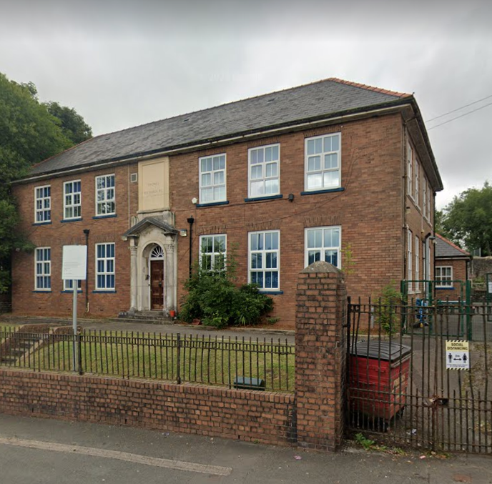
Events:  - Carousel Day  - Library Visit  - Valentine’s Day  - Toy Day  - NSPC Number Day  - Online Safety | Term dates:  - Last Day of Spring Term  17th February 2023  - Spring Term 2  28th February 2023 – 31st March 2023

Curriculum for wales: Mandatory elements
“The Act sets out the following mandatory elements which… span the 3 to 16 learning continuum:
- the cross-curricular skills of literacy, numeracy and digital competence
- the names of the areas of learning and experience (Areas)
- relationships and sexuality education (RSE)
- religion, values and ethics (RVE)
- Welsh
- English
https://hwb.gov.wales/curriculum-for-wales/summary-of-legislation/

Dosbarth…
  - Find out what your child has been learning in their class during this half-term’s topic ‘Metal Giants.’
  - Melyn
Mr Mates read the class novel, The Iron Giant to pupils daily. Pupils used Minecraft to create their own iron giant. During humanities, pupils investigated different types of transport and created a timeline. Pupils delivered a news report on sightings of the iron giant. During STEM, pupils learnt about materials that float and sink in water. Also, during STEM lessons, pupils were introduced to forces and made paper aeroplanes to learn about aerodynamics. During mathematics and numeracy, pupils learnt about Venn diagrams.
  - gwyrdd
During expressive arts, pupils created a water colour painting of the Statue of Liberty. Pupils studied the transport history timeline. Pupils researched the tallest buildings in the World. During expressive arts, pupils designed their name using graffiti. During a STEM session, pupils built structures that float in water. Pupils designed and researched paper aeroplanes and then took part in a flying competition. During expressive arts, pupils drew a half human, half robot face. Pupils researched love spoon symbols and meanings. Pupils studied the industrial revolution. Pupils also used Lego for robot building and coding.
  - Glas
Pupils designed a front cover for their work books. Pupils made a moveable robot out of card and tin foil. Pupils followed instructions to create moving cars using forces, blowing a balloon. They also investigated tall models and bridges. During expressive arts, pupils drew a robot. During STEM sessions, pupils learnt about gas, liquids and solids, as well as making a boat that would float or sink. Pupils also researched parts of a submarine and then drew a submarine. During expressive arts, pupils drew a half human, half robot face. Mrs McInnes also read the class novel, The Iron Man to the pupils daily.
  - Coch
Pupils investigated the floating and sinking of objects after learning about the Titanic. They also learnt about aerospace engineering by making paper aeroplanes. Pupils then completed test flights and made modifications to make their paper areoplanes more dynamic. Pupils participated in rocket launching. Pupils designed and made robots using junk materials. They also made a moveable robot arm. Pupils designed and made a love spoon out of clay for Valentine’s Day.

Topic for the next half-term is:
Fabulous festivals

