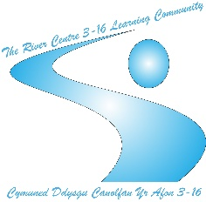
Newsletter
SECONDARY CAMPUS

TY AFON CAMPUS
The staff and students have been looking at the small garden at the back of the Ty Afon site and considered ways to improve it. The school would like to promote the importance of being more environmentally aware and would like to encourage greater biodiversity by introducing ‘bee friendly’ plants, bird feeders and building bird boxes with the support of students.

On the 27th January, learners reflected on the Holocaust in a special assembly. They listened to the story of Arek Hersch, a Polish Jew who survived the Auschwitz –Birkenau concentration camp. This offered students the opportunity to reflect on the of being a Jewish child during World War II and to share a collective moment of remembrance.

ARC PROVISION

2023 started off with some manual work; clearing the overgrown pathways and roads using the 360-degree digger and dumper truck. All learners showed team work, swapping between machines and using clear communication to ensure the tasks were completed safely and to a high standard.


Drainage channels have been dug and constructed to drain away excess water from the site. In addition, learners have begun examining block paving, identifying the similarities and differences between patterns and techniques.
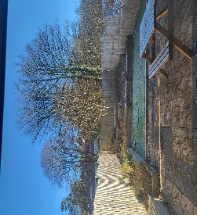
More recently, the learners have cleared out and around an inspection chamber and have started to repair it, laying new bricks to build it back up so a manhole lid can be fitted.

CWM PROVISION

Spaghetti houses, cup towers and foil boats!
STEM activities for our challenge lessons!

As part of our daily timetable, learners have been attempting challenges for our “challenge activity.” As well as STEM activities, learners have mastered the perfect paper aeroplane and designed their own parachutes.

The learners at our Cwm Provision have developed a special relationship with the staff and volunteers at the Owl Sanctuary in Festival Park, which has been a firm favourite for rewards sessions in the afternoons.
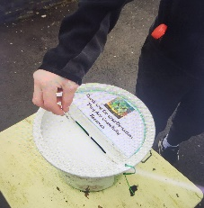
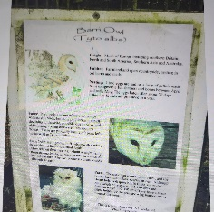

Summer Term 2023
*Start: Monday 17th April 2023
*Half term: Monday 29th May to Friday 2nd June 2023
*End: Monday 24th July 2023 (INSET) (Students finish on Friday 21st July)

DATES FOR THE DIARY!
Spring Term 2 2023
*Inset Day: Monday 27th February 2023
*Learners return: Tuesday 28th February 2023
*End: Friday 31st March 2023

