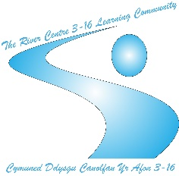
Newsletter
TY AFON





FOOTBALL FEVER
With the Welsh football team reaching the FIFA World Cup Finals for the first time since 1958, it was a time to celebrate with students at Ty Afon by putting up bunting and donning bucket hats. Students, as well as staff, watched Wales take on the USA in the first round of the group stages. Although the match did not live up to expectations, with a one all draw, students were treated to a feast of breakfast rolls served up by Ty Afon’s answer to Gordon Ramsay, Lisa Stevens!
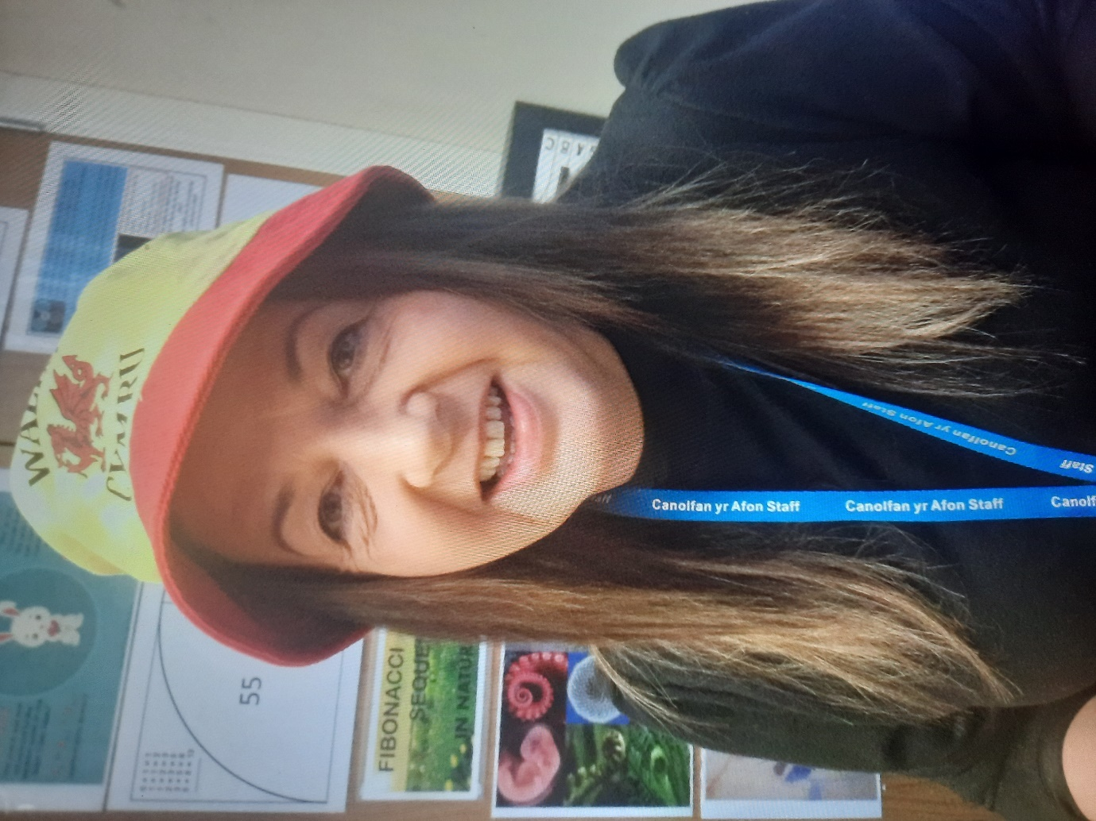
Lisa Stevens
Ty Afon’s Master Chef!

REMEMBRANCE DAY
In the week building up to Remembrance Sunday on the 13th November, students reflected on the importance to honour those who served and sacrificed their lives from Britain and the Commonwealth. Students played tribute by using their creative skills to make poppies from plastic bottles in the week leading up to the Sunday.

Students and staff also observed a two-minute silence at 11am on the 11th November (Armistice Day) to reflect on the sacrifice servicemen had made to defend the democratic freedoms of the country.
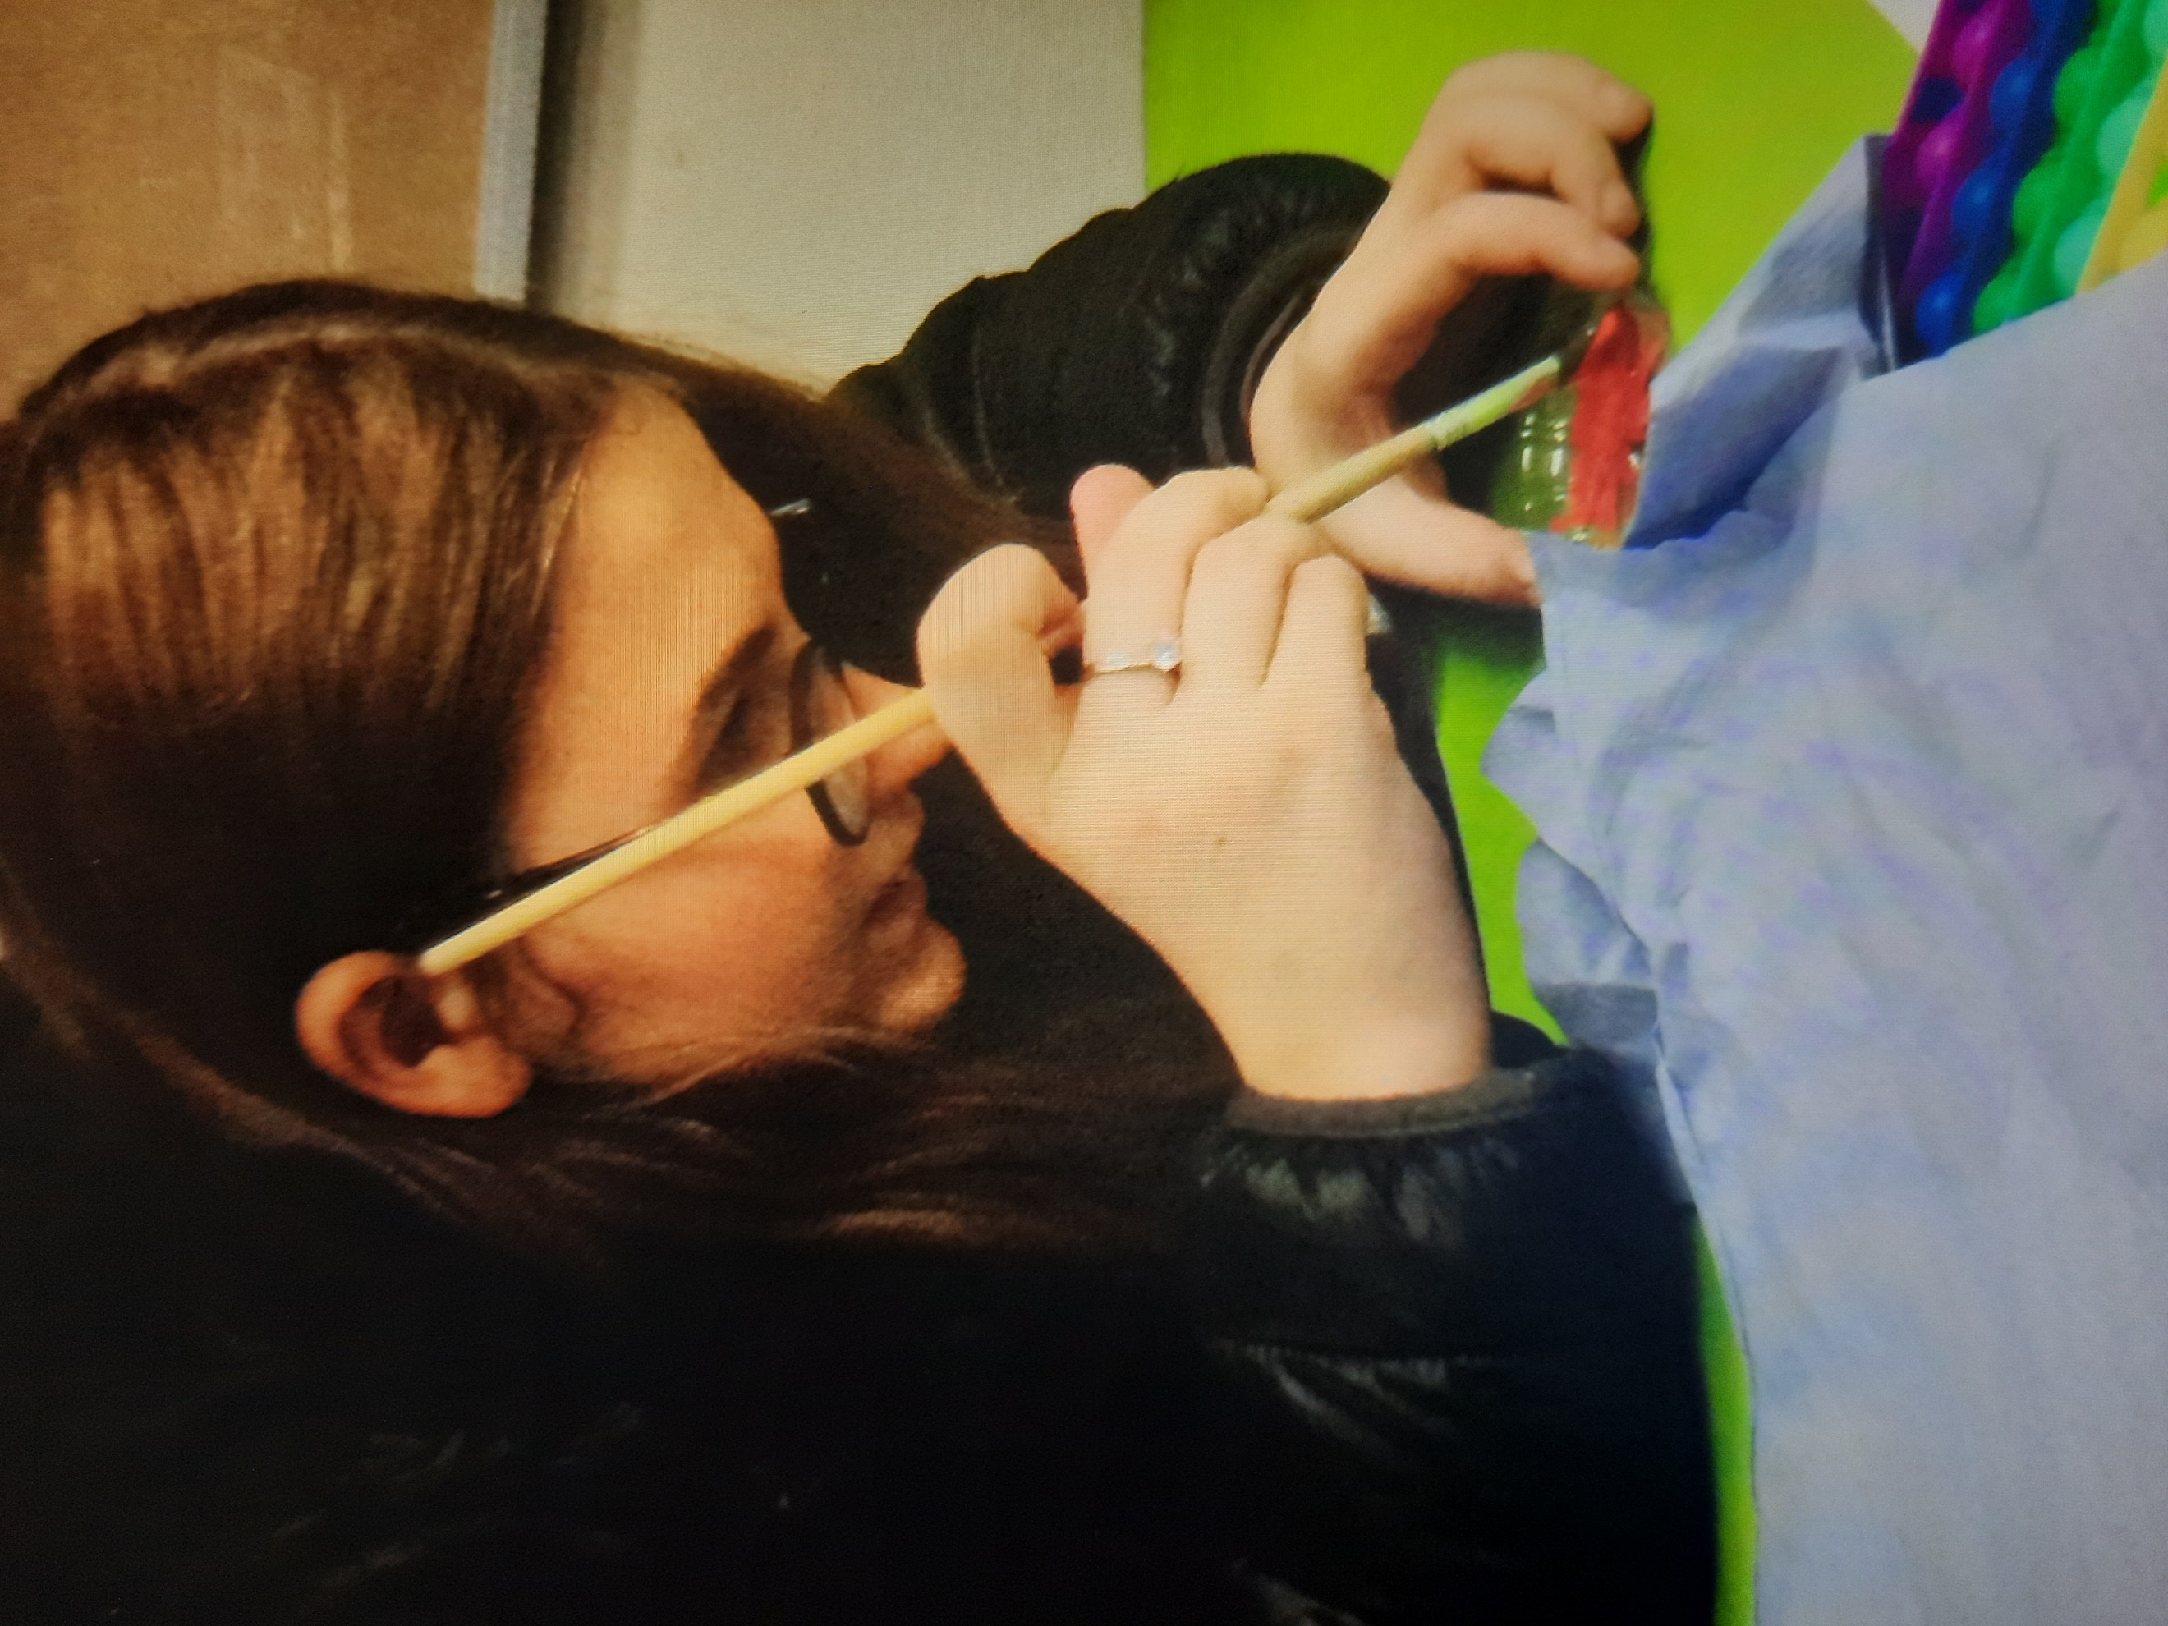
Painting poppys for Remembrance Sunday

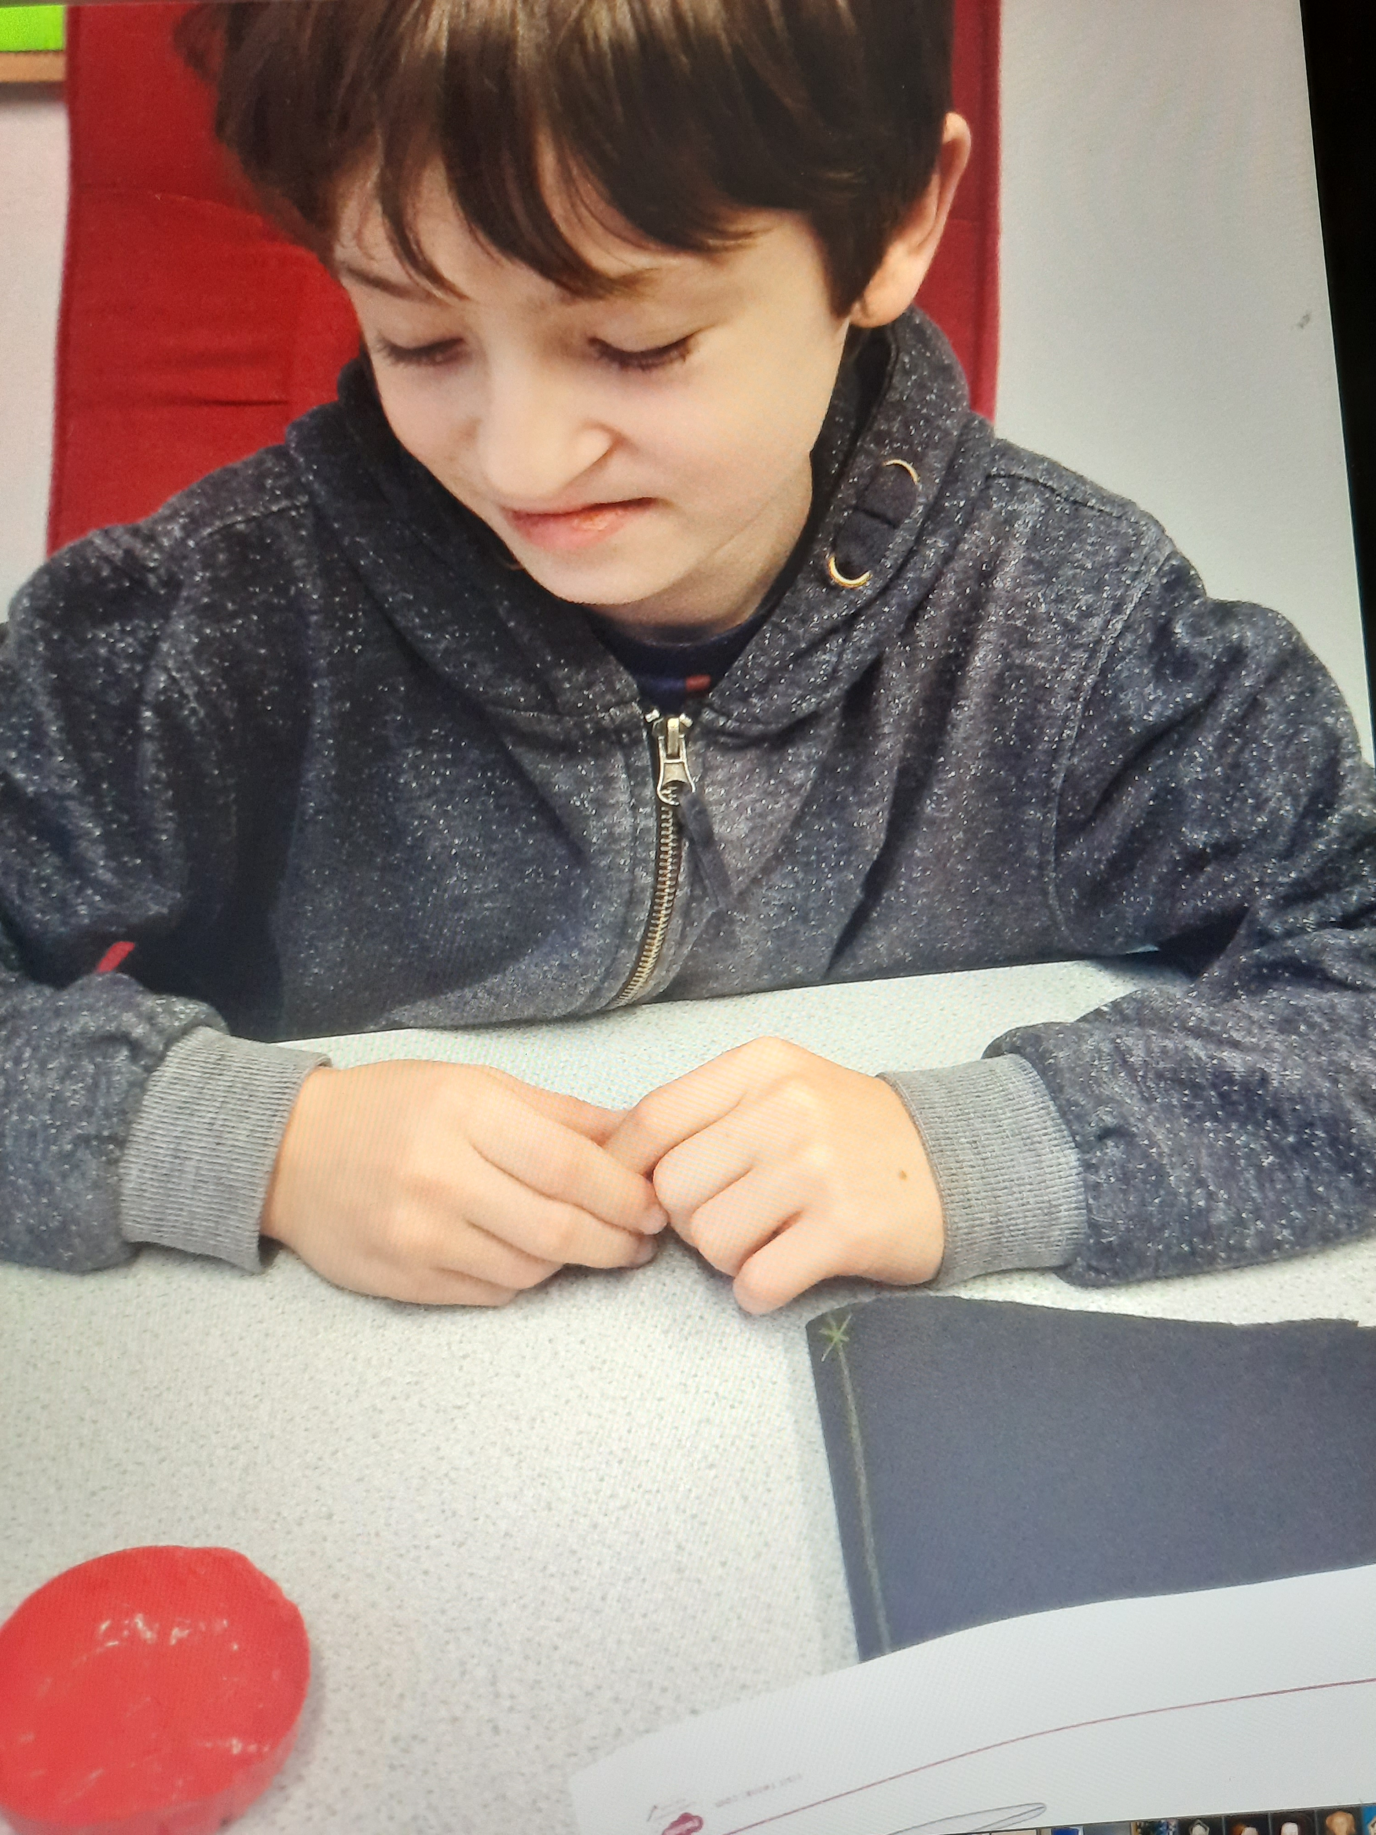
Making poppies for Remembrance Sunday

CHILDREN IN NEED
BBC’s Children in Need fundraising event to help support the most vulnerable children and young people in every corner of the UK and across the globe took place on the 18th November. Students at the Ty Afon site received an unexpected visitor when Pudsey Bear arrived in the car park. Teachers and students seized the moment to catch a photo with the famous bear who has now been the official logo of the charity for its 32 years existence.
STAR STUDENT
Star of the Half Term was newcomer Bobby who was awarded the accolade for the way he has settled in and embraced his education at the Ty Afon setting. Da iawn Bobby!
TIME TO SAY GOODBYE
The River Centre is sad to say goodbye to Mr Richard Parry who decided to call
time on his employment at The River Centre in order to pursue his other passion of woodwork. Mr Parry has served as a dedicated teacher at the Ty Afon site for 7 years. His wealth of experience and commitment to the wellbeing and academic success of the students has been paramount in developing resilient, confident learners. Mr Parry will be sorely missed and will leave some very big boots to fill. All at The River Centre would like to share their appreciation for the fantastic work he has done over the years and wish him all the best for the future!

NADOLIG LLAWEN!
Staff at The River Centre would like to wish students, parents and carers a Merry Christmas and a Happy New Year!
We look forward to seeing our young learners well rested and ready for the challenges in 2023!

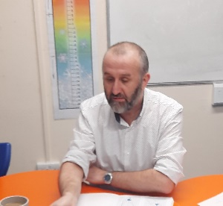
Mr Richard Parry

Pudsey comes to Town!
Staff and pupils take the opportunity to grab a photo with Pudsey Bear

DATES FOR THE DIARY!
Spring Term 2023
- Start: Monday 9th January 2023
- Half term: Monday 20th February to Friday 24th February 2023
- End: Friday 31st March 2023

Summer Term 2023
- Start: Monday 17th April 2023
- May Day: Monday 1st May 2023
- Half term: Monday 29th May to Friday 2nd June 2023
- End: Monday 24th July 2023 (INSET) (Students finish on Friday 21st July)

INSET Days
- INSET Day: Friday 23rd December 2022
- INSET Day: Monday 24th July 2023
Other INSET days to be confirmed.

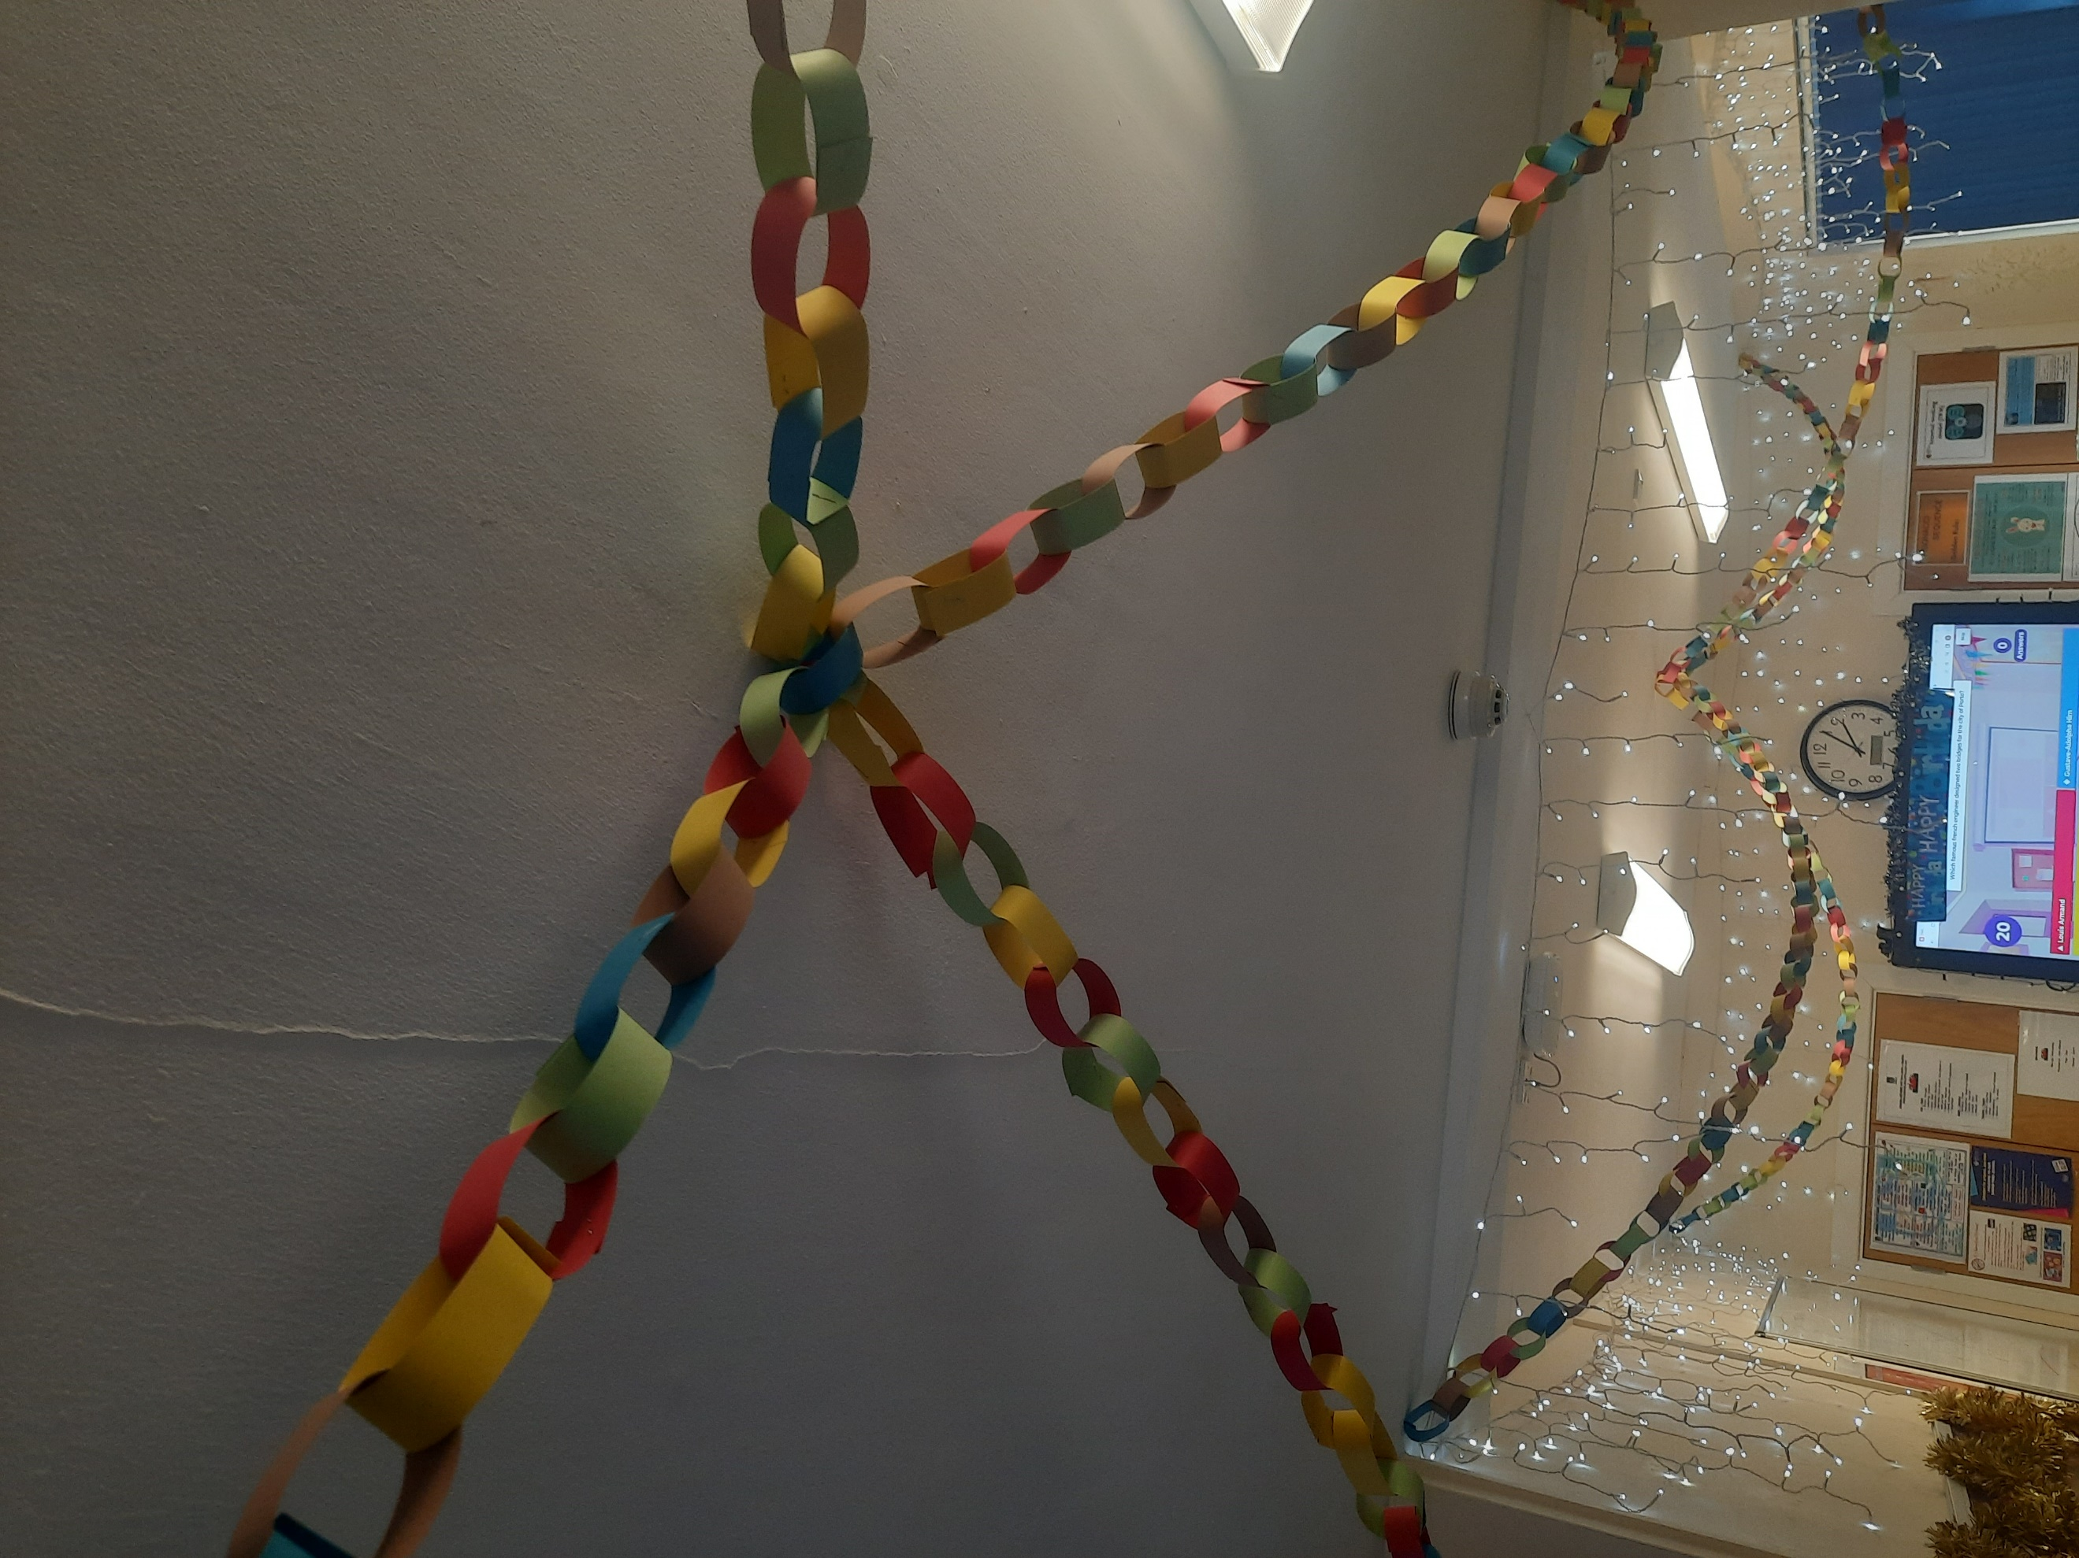
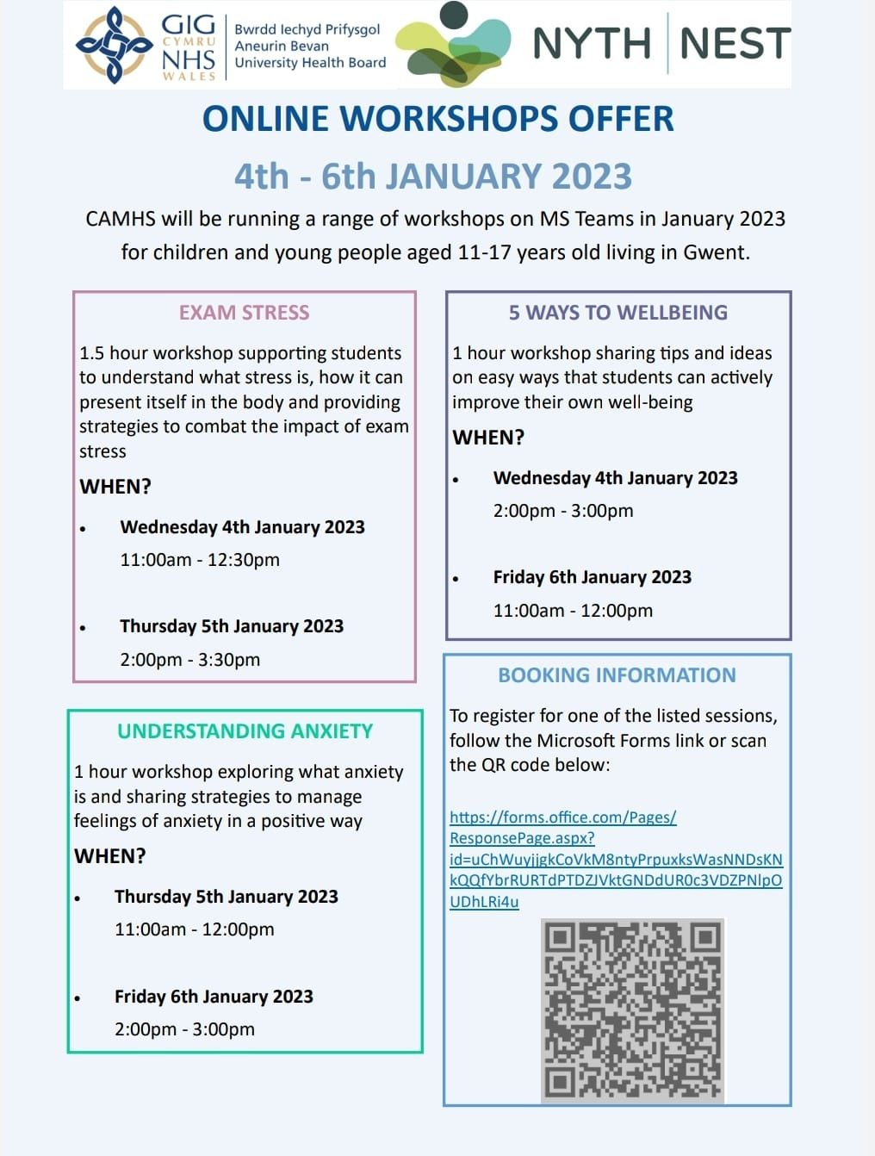
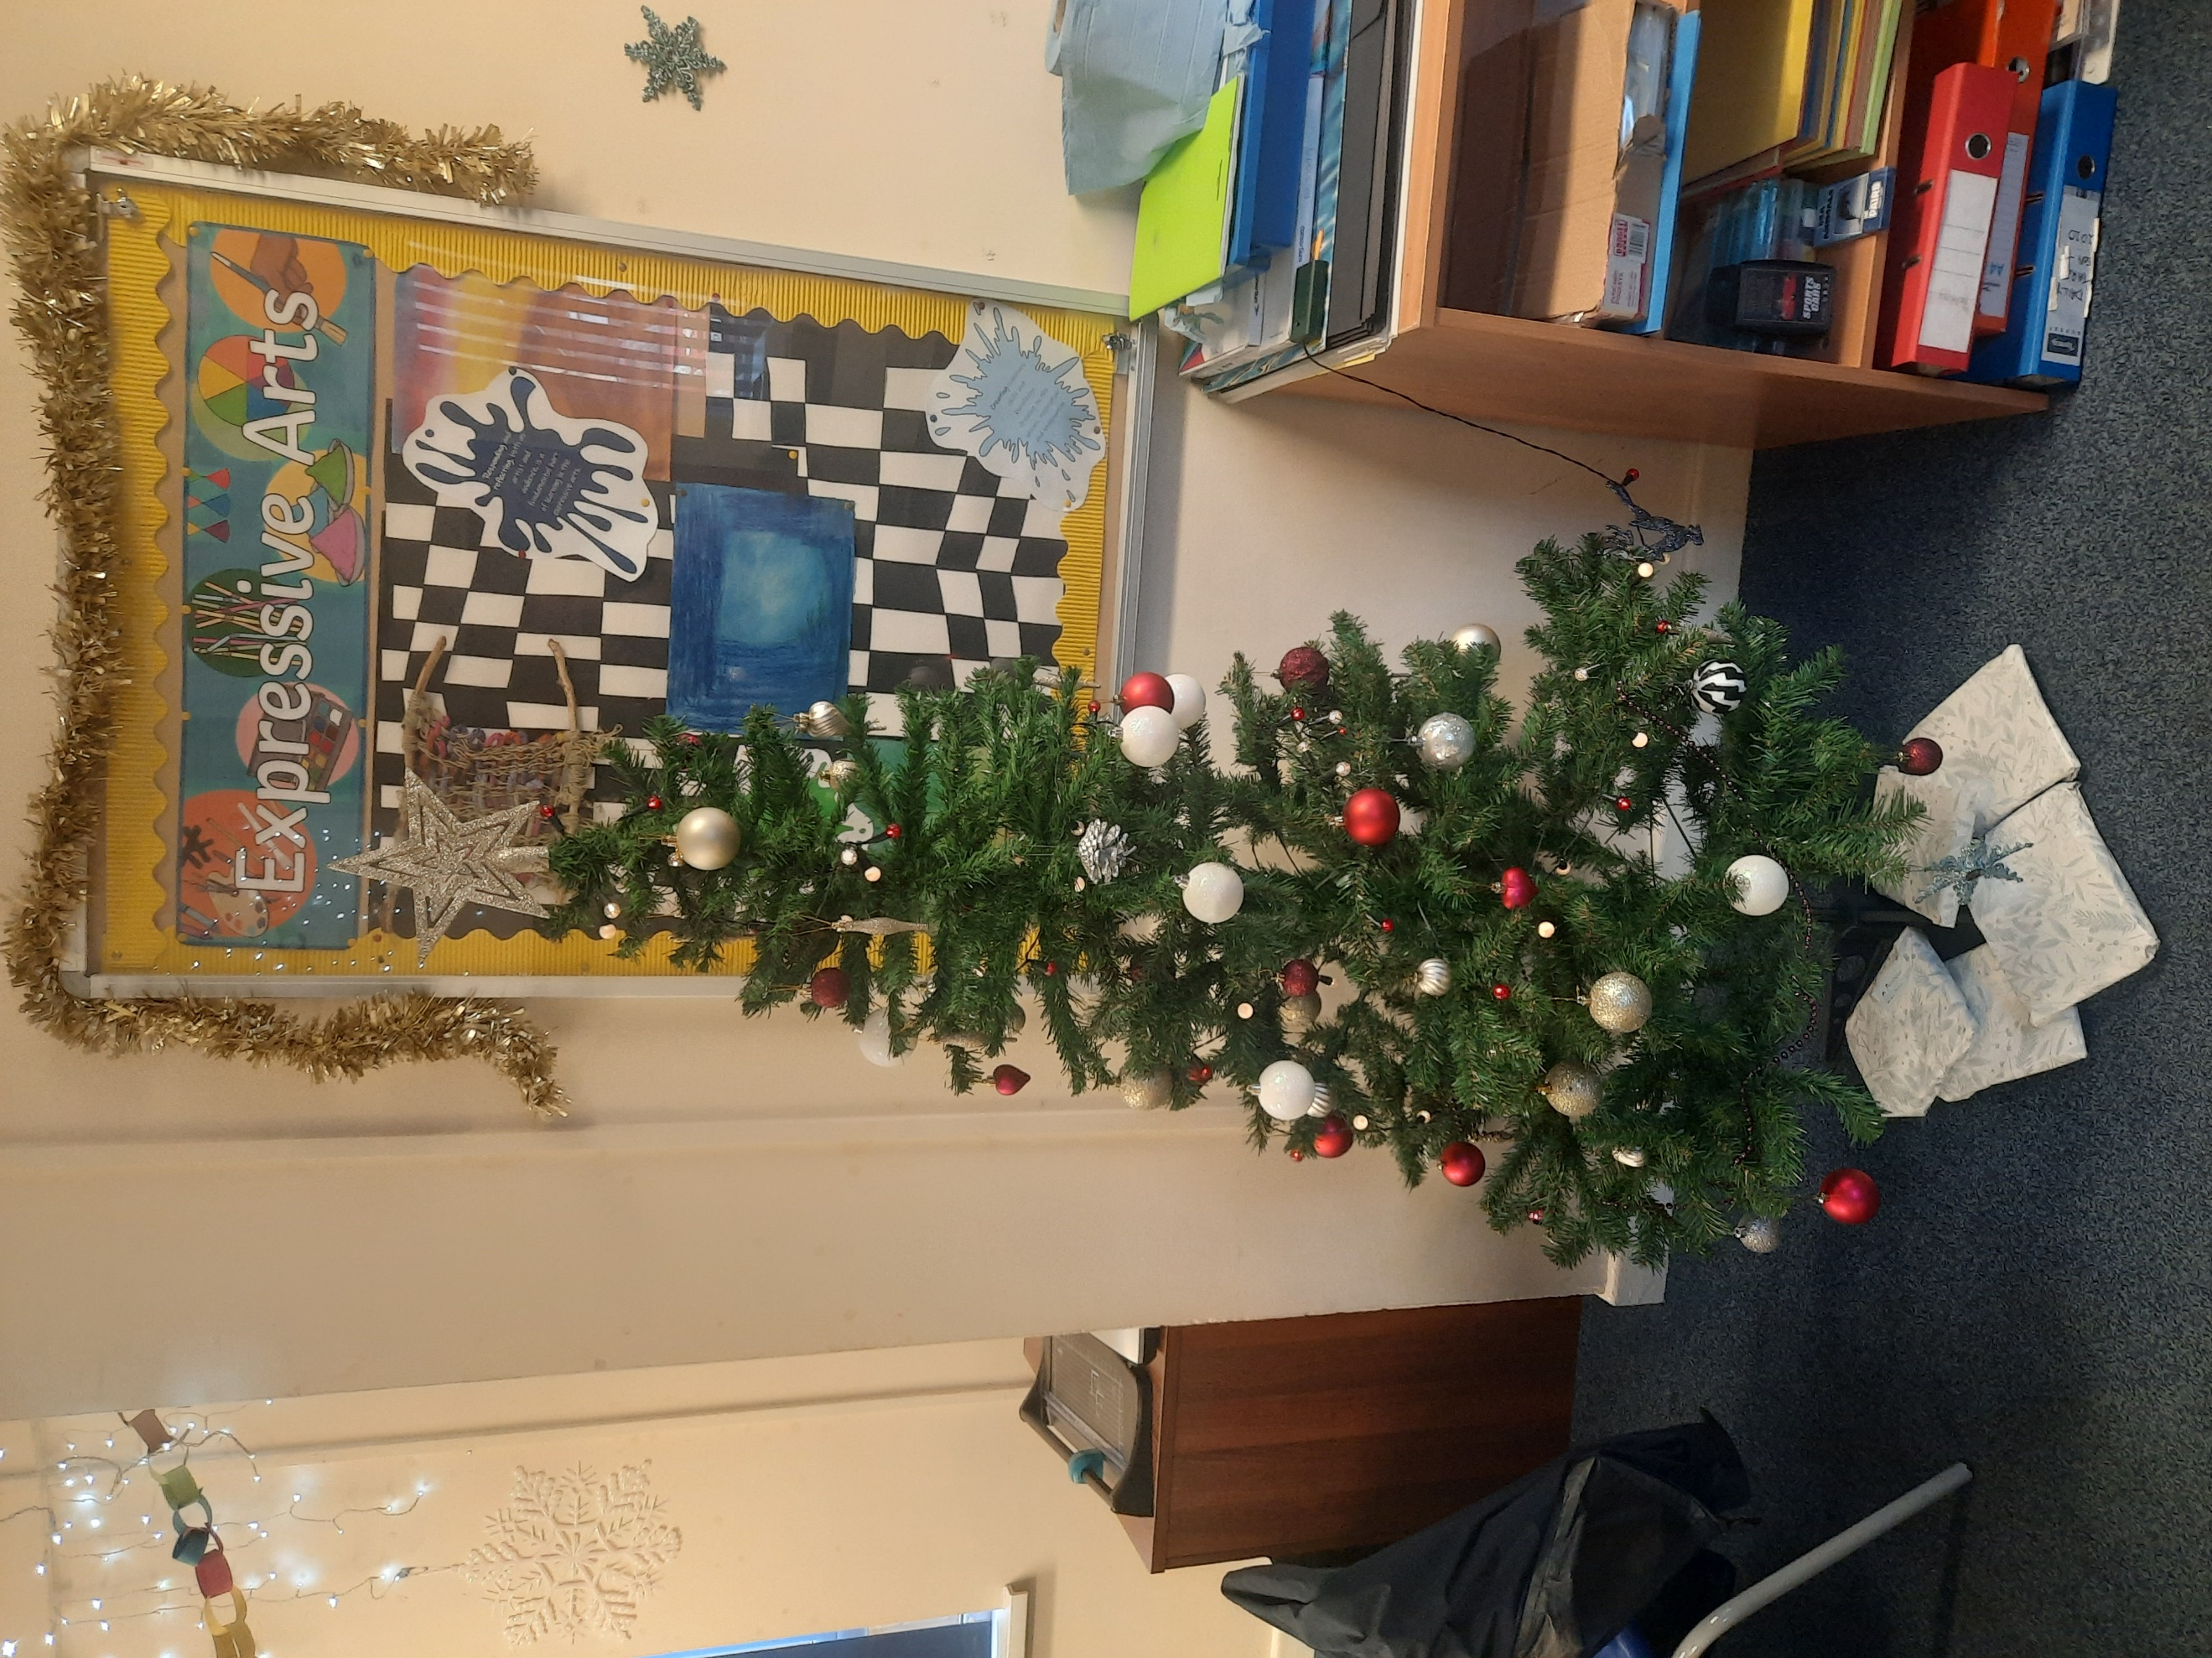
Ty Afon’s Christmas decorations created by students

Ty Afon’s Christmas Tree decorated by students

