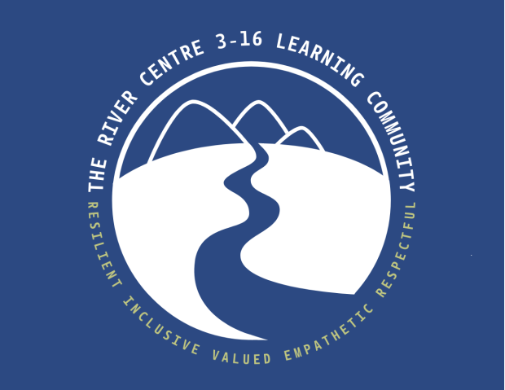

Curriculum Statement

Our Vision & Values

The curriculum is “everything a learner experiences in pursuit of the four purposes... It is not simply what we teach, but how we teach and crucially, why we teach it.” (CfW Guidance)
Our mission statement at The River Centre 3 – 16 Learning Community is, “Where Courage meets the Classroom, nurturing brave pupils every step of the Way.”
Our aim is simple, we will drive major improvements in every aspect of the school and we expect The River Centre 3 – 16 Learning Community to be a shining beacon of the learning community in Blaenau Gwent and beyond. When our learners leave us, they will be prepared and ready for a 21st century workplace, and have the skills, resilience and competencies to do this. Our vision for the school is to celebrate and promote the four core purposes of the Curriculum for Wales as the cornerstones of our education system in creating learners who are:
• Ambitious, capable, ready to learn throughout their lives
• Creative and enterprising
• Ethical, informed citizens/learners
• Confident and healthy individuals
Our curriculum is underpinned by our values of shaping learners that are Resilient, Inclusive, Valued, Empathetic and Respectful. These were chosen by our pupils and stakeholders, and are woven into every aspect of school life. They provide a frame of reference for our learning environment, defining what we value, expect and even the things that we praise and thank each other for.

Contents
How we are meeting the mandatory elements Page 3
Engaging with our community Page 4
TRC Charter Page 7
Teaching and Learning at TRC Page 6
Progression & assessment Page 7
Reviewing our curriculum Page 9

Glossary of abbreviations
AoLE – Area of Learning and Experience | RSE – Relationships and Sexuality Education
RVE – Religion, Values and Ethics | DCF – Digital Competency framework
PSE – Personal, Social Education | DT – Design Technology
T&L – Teaching and Learning | ICT – Information, Communication Technology
CAT – Cognitive Ability Test | AfL – Assessment for Learning

The table below explains how we are meeting the mandatory elements of Curriculum for Wales…
AoLEs & The Statements of What Matter… | Expressive Arts - Learners experience the Expressive Arts through their art and design– they will learn that… | Themes and activities in wellbeing check ins, reflection time and in lessons make links between AoLEs in a range of contexts  The cross-curricular skills of literacy, numeracy and digital competency and integral skills are delivered across the curriculum, as are the cross-cutting themes of RSE, Diversity, human rights and careers and work related experiences  We are committed to promoting the Welsh language and our common Welsh history and heritage
AoLEs & The Statements of What Matter… | - Exploring the expressive arts develops artistic skills and knowledge enables learners to become curious and creative individuals  - Responding and reflecting, both as artist and audience, is a fundamental part of learning in the expressive arts  - Creating combines skills and knowledge, drawing on the senses, inspiration and imagination
AoLEs & The Statements of What Matter… | Health & Wellbeing - Learners experience this AoLE through their PE, food, support from external agencies and their broader curriculum opportunities – they will learn that…
AoLEs & The Statements of What Matter… | - Developing physical health and wellbeing has lifelong benefits  - How we process and respond to our experiences affects out mental health & emotional well-being  - Our decision-making impacts on the quality of our lives and the lives of others  - How we engage with social influences shapes who we are and affects our health and well-being  - Healthy relationships are fundamental to our well-being
AoLEs & The Statements of What Matter… | Humanities - Learners experience this AoLE through a combined Humanities provision including Geography, History and RVE – they will learn that…
AoLEs & The Statements of What Matter… | - Enquiry, exploration and investigation inspire curiosity about the world, its past, present and future.  - Events and human experiences are complex, and are perceived, interpreted and represented in different ways  - Our natural world is diverse and dynamic, influenced by processes and human actions  - Human societies are complex and diverse, and shaped by human actions and beliefs  - Informed, self-aware citizens engage with the challenges and opportunities that face humanity, and are able to take considered and ethical action
AoLEs & The Statements of What Matter… | Languages, Literacy and Communication - Learners experience this AoLE through their LLC lessons – they will learn that…
AoLEs & The Statements of What Matter… | - Language connects us  - Understanding languages is key to understanding the world around us  - Expressing ourselves through languages is key to communication  - Literature fires imagination and inspires creativity
AoLEs & The Statements of What Matter… | Mathematics and Numeracy - Learners experience this AoLE through their maths lessons – they will learn that…
AoLEs & The Statements of What Matter… | - The number system is used to represent and compare relationships between numbers and quantities  - Algebra uses symbol systems to express the structure of mathematical relationships  - Geometry focuses on relationships involving shape, space and position, and measurement focuses on quantifying phenomena in the physical world  - Statistics represent data, probability models chance, and both support informed inferences and decisions
AoLEs & The Statements of What Matter… | Science and Technology - Learners experience this AoLE through their science, DT and embedded DCF skills – they will learn that…
AoLEs & The Statements of What Matter… | - Being curious and searching for answers is essential to understanding and predicting phenomena  - Design thinking and engineering offer technical and creative ways to meet society’s needs and wants  - The world around us is full of living things which depend on each other for survival  - Computation is the foundation for our digital world

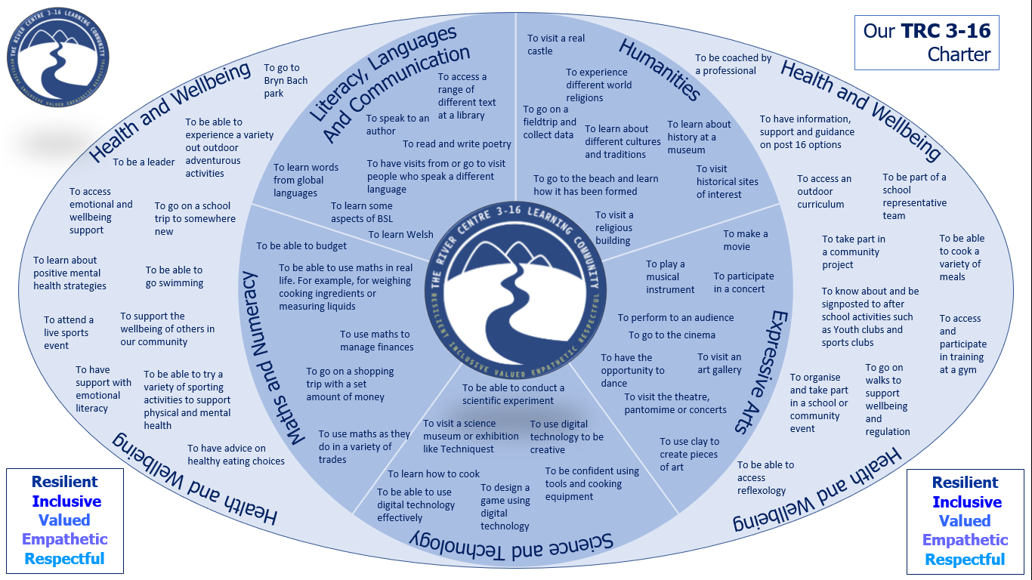

T&L at The River Centre 3-16 Learning Community
An excellent curriculum needs excellent teaching and learning (pedagogy).
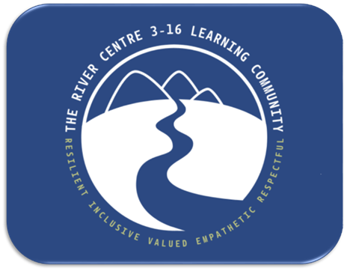
Curriculum for Wales is underpinned by 12 Pedagogical Principles for good teaching and learning:
Good teaching focuses on the 4 purposes of the curriculum, challenges pupils to sustain their efforts to reach high but achievable targets, employs a broad repertoire of teaching approaches, promotes problem solving, creative and critical thinking, builds on previous knowledge and experience and engages pupils’ interest, creates authentic contexts for learning, employs assessment for learning principles, makes connections within and across Areas of Learning and Experience, reinforces Cross-curriculum responsibilities including literacy, numeracy and digital competence, encourages pupils to take ownership of their own learning, supports social and emotional development and positive relationships and encourages collaboration.

The 12 Pedagogical Principles
Challenges pupils to sustain their efforts to reach high but achievable targets.
Employs a broad repertoire of teaching approaches.
Promotes problem solving, creative and critical thinking.
Creates authentic contexts for learning.
Encourages collaboration.
Supports social and emotional development and positive relationships.
Encourages pupils to take ownership of their own learning.
Makes connections within and across Areas of Learning and Experience.
Employs assessment for learning principles.
Reinforces Cross-curriculum responsibilities including literacy, numeracy and digital competence.
Builds on previous knowledge and experience and engages pupils’ interest.
Focuses on the 4 purposes of the curriculum.
Assessment & Progression…

If a learner is “progressing” they are developing and improving their skills and knowledge. Understanding progression means we understand how learners deepen and broaden their knowledge and understanding, skills and capacities and attributes and dispositions over time. Assessing how well learners are progressing informs our curriculum, our planning, allows us to track and monitor rates of progress and evaluate how well we are doing as a school.

Progression is vital for all:

- our learners make progress and are aware that they are doing so
- our staff know and reflect on their learners’ progress and adapt and refine their planning provision as appropriate
- leaders in the school track and monitor progress, evaluating the effectiveness of our provision to inform the ongoing improvement of our curriculum and pedagogy
- parents are aware of how their child is progressing, and where they need to go next

The Principles of Progression (as per the Progression Code) are:

- increasing effectiveness
- increasing breadth and depth of knowledge
- deepening understanding of the ideas and disciplines within the Areas of Learning and Experience
- refinement and growing sophistication in the use and application of skills
- making connections and transferring learning into new contexts

The descriptors of learning within each AoLE provide further clarity regarding progression – we have used them to:

- understand what progression means and should look like in a given AoLE
- develop the curriculum and learning experiences to enable learners to progress
- develop assessment approaches which will allow us to see whether progress is being made

With respect to assessment, at The River Centre 3-16 Learning Community we…

- engage in meaningful transition work that focuses on progression. Moderation activities between primary and secondary sites means we have a strong understanding of how learners have progressed

- assess learners on entry, and regularly thereafter, through the use of CATs

- assess learner’s progress at regular track-points, recording, tracking, monitoring and reporting on whether the development of the required knowledge, understanding and skills (to ensure expected progress) is as expected for them

- assess progress with respect to our school values (Resilient, Inclusive, Valued, Empathetic, Respectful)

- ensure appropriate intervention and support is provided where required

- ensure information relating to assessment and progress is accessible to school staff, so that they can evaluate and adapt their provision effectively in order to maximise progress of our learners

- provide regular reports of pupil progress, and ensure that information relating to assessment and learner progress is understood

- ensure information relating to assessment and progress is understood by learners to ensure they understand how they’re being assessed and the progress they’re making

- provide the opportunity for parents to feedback their thoughts on our assessment arrangements, to support continuous improvement of our practice

- involve learners in their assessment, increasing their ownership of their progress. For example, through learner contributions to formal reports and through the use of skilful AfL in the classroom

- trust each AoLE to use assessment strategies that best fit their curriculum and pedagogy. This could involve: Pupils maintaining evidence portfolios, formally assessed pieces of work, assessing classwork, tests or AfL / ongoing assessment

- map progress into our curriculum plans to ensure that each AoLE understands what progress looks like

- create AoLE level assessment plans – detailing how progress is assessed
Ongoing Curriculum Review …

Curriculum design is an iterative (ongoing) process. To ensure that our curriculum is kept under review and that we engage in meaningful revision of it, we will carry out regular, calendared and purposeful reflection, evaluation and redesign. This review will be systematic, and married with our school improvement processes and systems of governance. This process will involve asking the following questions to stakeholders at all levels:

- Does our curriculum enable and ensure learners to develop in the ways described in the four purposes? Will it develop the integral skills?

- Does our curriculum ensure learners make progress within the AoLEs? Is it coherent? How? How do we know?

- How well does our curriculum provide for the mandatory elements (e.g. skills) and what impact does it have on pupil progress and development? How? How do we know?

- Does our curriculum secure appropriate progression as per the Progression Code? How? Why? Can we explain what this looks like?

- Is our curriculum suitable for our learners? Their abilities and aptitudes? How do we know?

- Have we considered the evidence around best teaching & learning? How have / will we now amend our pedagogy to support progress and delivery of CfW?

- Is our curriculum broad and balanced?

- Does our curriculum provide opportunities for development and progress within the context of the cross-cutting themes (RSE, Human rights, Diversity, Careers and work-related experiences, Local, national and international contexts)?

- Do our (AoLE’s) assessment arrangements inform and support progression? How? Why?

- Is our curriculum static or evolving? How? Why?

- How can our curriculum be improved?

We will also seek critical feedback on the key points above from the Local Authority, Regional Consortium and School Improvement Partners.

